Your logo

Customer Phone# |  |  |  |  | License # |  | VIN# |  |  | Year | Make | Model
Quantity | Code |  | Description |  |  |  |  |  |  |  | Unit Price | Total
 |  |  |  |  |  |  |  |  |  |  | Subtotal
 |  |  |  |  |  |  |  |  |  |  | Total
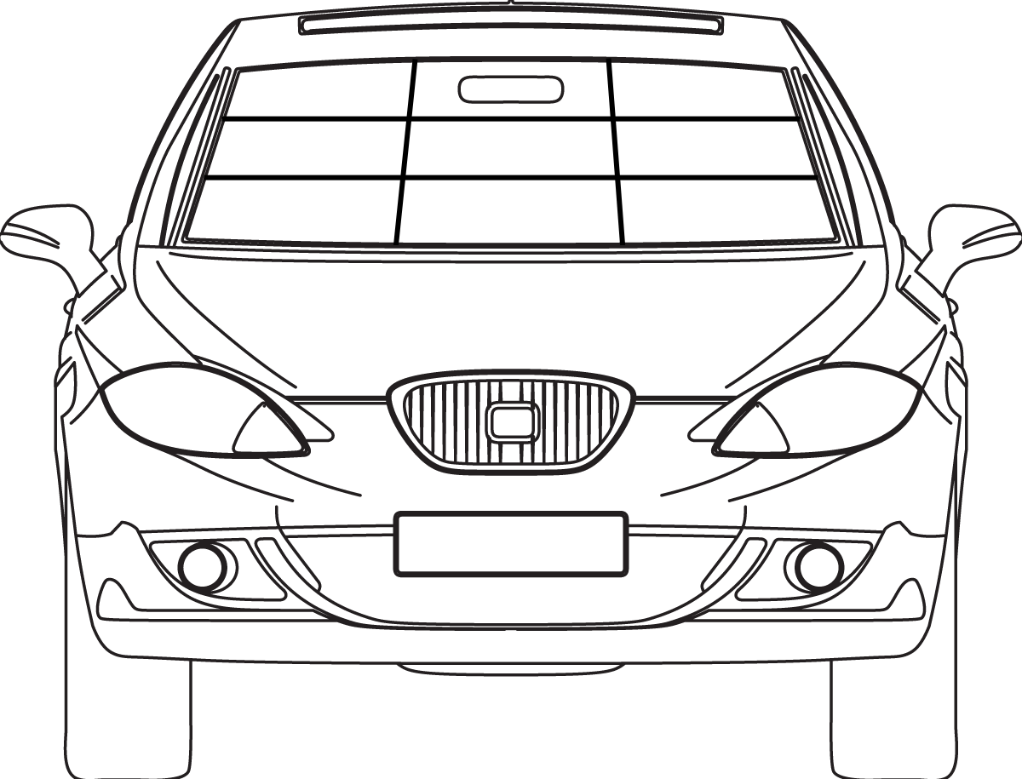
Code
A. | Driver Side Only
B. | Passenger Side Only
C. | Both Sides

Signature:__________________________________________________________
Date:___________________________
Billed To:

Sold To:
An Extended Service Plan is available for this vehicle. Simply bring your vehicle back every 12 months at a fraction of the cost of the original restoration. You must bring this vehicle in within 10 days of warranty expiration to be eligible for this Extended Service Plan. Additional extended plans are available, see your Service Warranty.

