Your logo

Policy # |  |  |  |  | License # |  | VIN# |  |  |  | Year |  | Make | Model
Insurance Company |  |  |  |  | Agent Name |  |  |  | Agent Phone # |  |  | Claim Authorization # |  | Date of Loss
Quantity | Code |  | Description |  |  |  |  |  |  |  |  |  | Unit Price | Total
 |  |  |  |  |  |  |  |  |  |  |  |  | Subtotal
 |  |  |  |  |  |  |  |  |  |  |  |  | Total
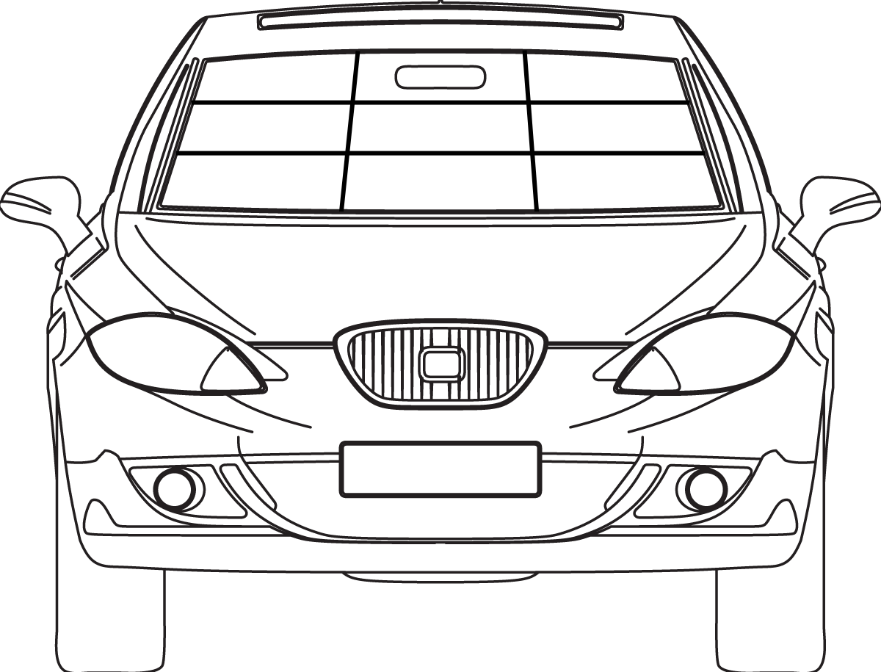
Code
A. | Bulls Eye
B. | Combination
C. | Star
D. | Crack (Specify Length)

I the undersigned, authorize my insurance company to pay_______ for all parts and services listed on this invoice. If my insurance company refuses to pay for part or all of the total cost of these parts and services, I understand that I am responsible and agree to pay these charges within thirty days. If I do not have insurance coverage, I agree to pay in full at the time service is rendered unless prior arrangements have been made with ______. Due to the process of using pressure and vacuum cycles to repair laminated glass and the unstable properties of broken glass, the damaged area may develop additional cracks or existing cracks may increase in length. This problem is very rare and occurs in less than .1% of all windshield repairs performed. In the unlikely event that we cannot repair the damage to your satisfaction, our liability is limited to a refund of any amount charged for the attempted repair. I have been instructed as to the expectations; warranties and disclaimers involved with windshield repair and understand _____ policies regarding these matters. Signing below indicates that you have read and agree to the terms set herein.

*Money Back Guarantee: You are entitled to a full refund if this repair does not stop the damage from spreading for as long as you own the vehicle.

Signature:__________________________________________________________
Date:___________________________
Billed To:

Sold To:

